多语种中心欢迎您修读本学期的现代希伯来语课程：
课程代码 | 课程名称 | 任课教师 | 教室 | 上课时间
FORE110083.01 | Modern Hebrew Language I | Miri Beck | H5418 | Mon.8-9，Thu.8-9  1-17

关于现代希伯来语
It’s one of the world’s oldest languages. It was pretty much a dead language (the spoken part of it, at least) until it was resurrected and re-popularized by Eliezer Ben-Yehudah. Here are some facts to get you acquainted:
希伯来语是世界上最古老的语言之一。它曾是一门几近失传的语言，直至Eliezer Ben-Yehudah让它重新焕发生命力并再次走向世界。关于希伯来语你需要了解更多：
- Originally started over 3 to 4 thousand years ago.
- Over 10 million speakers worldwide
- Hebrew contains 22 characters
- Written and read from right to left.
- Verbs have different genders depending on the speaker
- Modern Hebrew is used as the current language. Biblical Hebrew is used for prayer.
- Learning Modern will help you with Biblical Hebrew – but more importantly – allow you to speak with real Israelis.
- 起源于三四千年前。
- 在全球拥有超过一千万的使用者。
- 包含22个字符。
- 从右到左阅读和书写。
- 动词可以有不同的性别，这取决于使用者的性别。
- 不同于祷告用的古希伯来语（也称圣经希伯来语），现代希伯来语是一门当今社会仍在使用的语言。
- 现代希伯来语的学习可以帮助你了解圣经希伯来语，不过最重要的是，学会这门语言，你可以和真正的以色列人对话。
How to read & write Hebrew
You need to learn the Hebrew alphabet – also known as the Alefbet. There are some tricky parts:
- as mentioned above, it’s written and read from right to left.
- these characters are completely different.you WILL need to write them out again and again.
- there are no vowel “letters.” Instead, there are patterns of lines/dots around characters that signify which vowel the consonant uses.
如何阅读和书写希伯来语
你需要学习希伯来文字母，也称Alefbet。 以下是需要注意的难点：
正如前面所提到的，希伯来语的阅读和书写顺序是从右到左的。
这些字符和你以往学到的其他语言的字母是完全不一样的，你需要不断练习直到完全掌握。
希伯来语中没有表示元音的“字母”，字符周围的点线符号会标识辅音所跟的元音。

希伯来语22字符
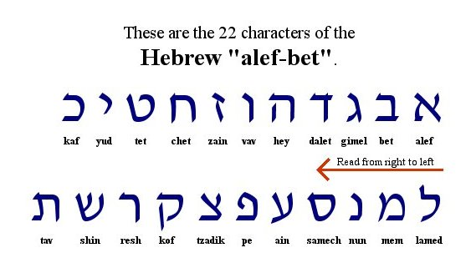
我们的课程
In the course we will learn:
* The mystical language the ancient Hebrew language that was revived and its’ miracle.
*The Bible (Old Testament) as a source to the Hebrew language, as a literature and History.
*The traditions of the Judaism and the circle of life of the Jews.
*The life in Israel in the Middle East, about the innovations and
Discoveries that gave Israel so many Noble Prizes.
通过该课程你将会学到：
古老神秘的希伯来语及其奇迹般的“复活”历程。
现代希伯来语之根《圣经》旧约的文学典故和历史，
犹太教传统及犹太人的历史。
中东地区的以色列人的生活，以及帮助他们拿诺贝尔奖拿到手软的发明和发现。
我们的老师
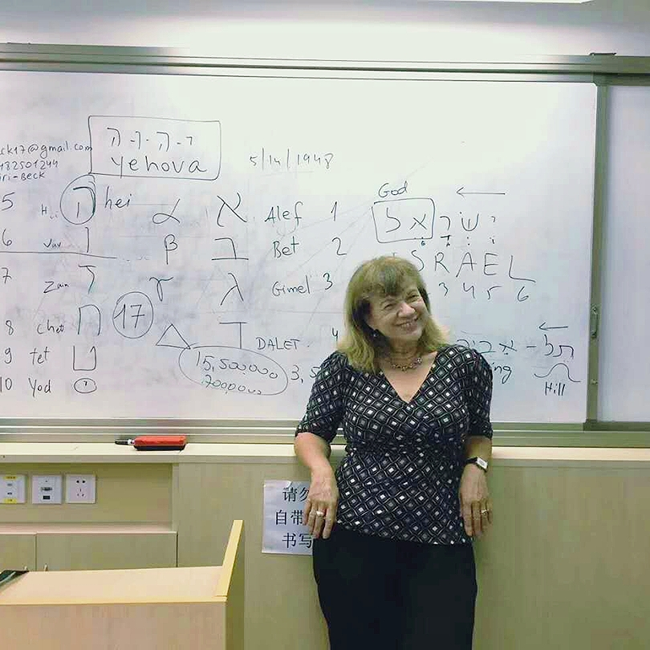
My name is Miri. I’m a professional Hebrew and English teacher.
Very enthusiastic and passionate about teaching and specially Hebrew and Israeli studies. I feel like the best ambassador of Israel.
I was born in Romania, grew up in Israel, and moved to Shanghai about 4 years ago.
I am a certified Hebrew and English teacher with a Master degree and 2 teaching certificates in Arts and in English, from the Tel Aviv University, Israel.
I have a very strong sense for languages – I speak, read and write, 4 of them: English, Hebrew, Hungarian and French. Therefore I have a personal experience in learning a new language.
I’ve been teaching Hebrew in Shanghai for the past 4 years in SISU
And in Israel I taught Hebrew as second language to many new immigrants that keep coming to Israel from all over the world. I also taught in High Schools and the Open University and Tel Aviv University.
I have been working with many people from young children to students, adult and businessmen.
Since learning a new language is a complicated matter, and can be taught in many ways. I use different techniques that are adjusted to each student and answer their demands and needs.
Besides teaching the language, I use my other skills and qualifications to teach Hebrew with songs, poems, films, visiting the Jewish Refuges Museum and other Jewish sites in Shanghai.
I simply love to teach and to provide people tools for success that can open many doors for them, in translation and business with Israelis entrepreneurs. They will be able to read the Bible in the original language.
Hebrew is not just a language it is a way of thinking. The language of ancient and outstanding wisdom that proved its power till today.

我叫Miri，是一名希伯来语和英语教师。我热衷教书育人，也对希伯来和以色列研究也十分入迷。我自认为是最出色的以色列使者。我生于罗马尼亚，长在以色列，于四年前迁至上海。在以色列的特拉维夫大学获得硕士学位和教师资格证后，我成为一名正式教师。我通晓四国语言：英语，希伯来语，匈牙利语和法语。因此在学习外语方面我有自己的一套经验方法。
我在上海外国语大学教了四年希伯来语。在以色列时，我负责希伯来语第二外语教学，我的学生都是从世界各地涌入以色列的移民朋友。此外，我在高级中学，开放大学（以色列特拉维夫市）和特拉维夫大学都有执教经历。我教过各种各样的学生，有老有少，有学生，也有商人。
学习一门新的语言是困难的，而老师教授的方法也各有千秋。因此我会因材施教，满足不同学生的水平和需求。除了课堂语言教学，我也会通过教学生唱歌，颂诗，看电影，参观犹太难民博物馆和当地犹太人聚集地来达到形式多样，生动丰富的立体教学效果。
授人以鱼不如授人以渔，我希望学生们可以通过希伯来语的学习探索更加广阔的世界，不仅能读懂古老希伯来语书写的《圣经》，更能够将其运用在翻译甚至和犹太商人的商务沟通方面。
学习希伯来语不仅是掌握一门语言，更是获得一种思维方式。希伯来语历经时间的洗礼仍旧生生不息，其智慧的光芒闪烁至今。

Our class book教材介绍
“Hebrew from Scratch” part 1 + CD (audio)
By :Shlomit Chayat, Sara Israeli and Hilla Kobliner
PublisherL The Hebrew University Students’ Printing and Publishing House. Jerusalem 2000
