多语种中心欢迎您修读本学期的现代希伯来语课程：

课程代码 | 课程名称 | 任课教师 | 教室 | 上课时间
FORE130502.01 | SECOND FOREIGN LANGUAGE (Portuguese) I | André Bernardo | H5413 | Mon.8-10，Thu.8-10  1-17
FORE110064.01 | Portuguese I | André Bernardo | H5413 | Mon.1-2，Thu.1-2  1-17

关于葡萄牙语

The concept of major or minor languages certainly varies, and Portuguese is a good example of that, as for a language that was spoken in one tiny country in western Europe, throughout history it became a language spoken in every continent of the world, and also with a exceptional historical relation with Macao Special Administrative Region of the People’s Republic of China.

Being the sixth most spoken language in the world with over than 215 million of native speakers, it is also the third-most spoken European language worldwide, and the major language in the Southern hemisphere, as well in South America. Other than being a growing language in the business world, which is spoken by a large part of the world population, Portuguese is a beautiful and romantic language with a great variety of artistic and cultural representations such as music (Fado and Samba) but also literature, poetry, cinema, architecture or painting.

主要或次要语种的概念是截然不同的，葡萄牙语就是一个很好的例子。这门被西欧一个小小的国家使用的语言曾在人类历史上被世界各个大陆广泛使用，它与中国澳门特别行政区也有一段特殊的历史渊源。
作为世界第六大口语，葡萄牙语拥有超过2.15亿的母语使用者，同时，它是全球范围内口头使用频率第三大的欧洲语种，也是南半球地区（以南美洲为主）的主要语言。除了在商务往来中使用人数越来越多，葡萄牙语还是一种以其美丽而闻名的浪漫语言，并且拥有丰富多样的艺术和文化表现，如音乐（葡萄牙民谣和桑巴舞），文学，诗歌，电影，建筑或绘画。

我们的课程
Course Syllabus and Methods
Thus, being a result of the significant political relations between Portugal and China, this course aims to give an extensive approach to the Portuguese language, both its cultural and linguistic aspects. Accordingly this course is built upon the most up-to-date language and communicative tools of the standard European Portuguese, but it is also designed to fulfill the students within the economical, political and socio-cultural environment attached to the language.

The course will focus on communicative and cognitive perspectives. The curriculum of the Portuguese language course targets the progress on every significant linguistic branch: grammar, reading, writing, listening and speaking, with a portion of time destined to each one of the branches in every class.

考虑到中葡两国间的重要关系，该课程旨在从文化和语言学两方面为葡语学习提供更广泛的方法。因此课程以欧标现代葡语为设置基础，同时也不忘以其政治经济，社会文化等背景知识来达到全方位的理想学习效果。
该课的教学法主要以语用交流和语言认知两大方向开展，其间穿插交际互动和语法学习内容。课程设置涵盖语言学习的每一项重要板块：语法，阅读，写作，听力和口语。教师根据各班在相应板块的学习情况决定时间分配。

我们的老师
Mr. Bernardo is a native Portuguese with an extensive teaching experience. He has a Bachelor’s degree in Portuguese language and linguistics and a Master’s in Portuguese Arts and Literature by the University of Lisbon. He has been teaching and lecturing overseas for the past 5 years, with teaching experiences in countries such as Portugal, France, Australia and East Timor.

Bernado是一名经验丰富的葡萄牙老师。他毕业于里斯本大学并获该大学葡语语言文学学士学位和葡萄牙文学艺术硕士学位。Bernardo曾在葡萄牙，法国，澳大利亚和东帝汶等国执教，拥有超过五年的海外授课经验。

Students Opinions on Portuguese language:

Jessica, student of the Foreign Languages Department

I am so glad to choose Portuguese as my second foreign language.

Before I go to your class, I learn the knowledge of Portugal from the history book. I know that Portugal is good at navigation in all times, which makes me feel familiar. Because my hometown is near the sea and I also enjoy the feeling on the boat. Since China is far away from Portugal, I cannot imagine what the daily life of the Portuguese people is like. Do they often go fishing on the sea like us? The curiosity is always pushing me ahead. But all my impressions on Portugal stop at the superficial layer. To learn more about the country, I choose to learn its language. The process must be very difficult, but I think it is worthwhile to do so.

Besides, at the moment, China is in deep cooperation with Portugal not only in business but in culture. And with the development of “one belt and one road”, the potential of the cooperation is growing up. The first step to communicate with Portugal, I think, is learning the language. The language is like a window open to a different country which provides us a precious chance to look into it. Thus I feel it significant to learn Portuguese well.

Even though I am a beginner at Portuguese, I hope I can learn it well and make contribution to the communication between China and Portugal.

Celia, student of the Foreign Languages Department, English major

Portuguese is the third most spoken European language in the world. Learning Portuguese allows me to communicate with dozens of people who come from other countries and thus to make more friends. In addition, it is an essential and fantastic means to connect China and European countries, helping both countries develop a good relationship. Since I would like to work in Macau where is a good platform for taking the first step of getting a rapport with these countries, it will be fabulous for me to have good Portuguese for my career as well as my own interest.

Jessica，复旦大学外文学院学生
“我很高兴选择葡语作为我的第二外语。上这门课之前，我在历史书上学到过葡萄牙这个国家。无论处于什么时期，它一直在航海领域出类拔萃，这使我觉得亲切。因为我的家乡也临近大海，我特别享受乘船渡海的感觉。但是中国离葡萄牙实在是太远了，我无法想象葡萄牙人的生活是怎样的。他们也像我们（家乡的人）一样经常出海捕鱼吗？对这个国家的好奇一直驱使我去了解更多，然而我对葡萄牙的了解也仅停留在表面印象。 为了深入了解这个国家，我选择去学习它的语言。我深知这个学习的道路将会布满荆棘，但是我认为一切都是值得的。
此外，今日的中国与葡萄牙不但有商业往来，更有文化交融。随着‘一带一路’政策的贯彻落实，中葡之间的合作空间也将潜力无穷。合作交流的第一步就是去学习这门语言。 一门语言是一扇窗，通过这些宝贵的窗口，我们得以窥见不同的国家。因此把葡萄牙语学好是很有必要的。
尽管我还只是个初学者，但我仍然希望能学好葡语，为中葡两国的交流合作做贡献。”

Celia，复旦大学外文学院英语专业学生
“葡萄牙语是欧洲第三大最常使用的口头语言。 学习葡语使我能够和世界各地的人交流并成为朋友。 除此之外， 这也是一种加强中国和欧洲国家联系，建立友谊的重要方法。 我以后想去澳门工作， 那里有更广阔的国际交流平台，因此学习葡语不仅可以满足我的兴趣爱好，也对我未来的职业生涯有诸多益处。”

Portuguese Textbooks
Language learning Books

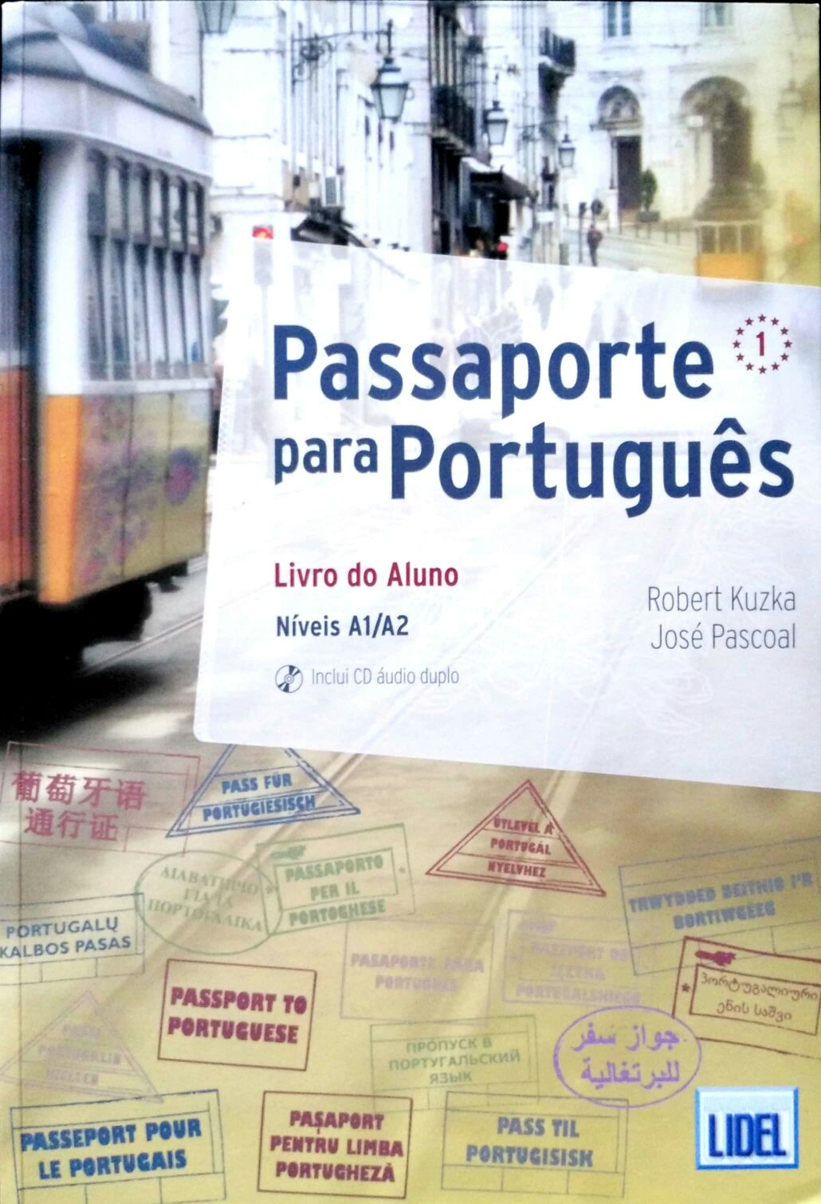

Grammar Book

