多语种中心欢迎您修读本学期的瑞典语课程：
课程代码 | 课程名称 | 任课教师 | 教室 | 上课时间
FORE110054.01 | Swedish I | Lin Maria Erica Engdahl | HGX206 | Wed.11-12 Fri.11-12  1-17

关于瑞典语
Swedish, the official language of Sweden, belongs to the North Germanic sub-group of the Indo-European language family. Swedish is spoken by almost 10 million people. Around 9 million people are native Swedish speakers, of which 8.5 million live in Sweden. In Finland, Swedish is the first language of approximately 6 percent of the population.

瑞典语是瑞典的官方语言，属印欧语系的北日耳曼语族。在瑞典的1000万人中， 约有900万人以瑞典语为母语，其中850万人居住在瑞典。在芬兰，瑞典语是大约6％人口的第一语言。

我们的课程

Fall semester: The course is for learners with no knowledge of the Swedish language. The content corresponds approximately to level A1 of the Common European Framework of Reference for Languages, and provide a basic knowledge of day-to-day Swedish language and grammar.

秋季学期：该课程适用于零基础的瑞典语学习者。其内容大致对应于瑞典语欧标A1水平。通过学习，学生可掌握瑞典语的日常用语和基础语法。

Spring semester: The course is for learners with basic knowledge of Swedish language and grammar. The content of the course corresponds approximately to level A2 of the Common European Framework of Reference for Languages. At the end of the course learners should be able to speak and understand basic conversational Swedish.
春季学期：本课程针对初具瑞典语基础知识和语法的学习者开设。课程的内容大致对应于瑞典语欧标A2水平。在课程结束时，学习者应该能够说出并理解瑞典语的基础会话。

我们的老师

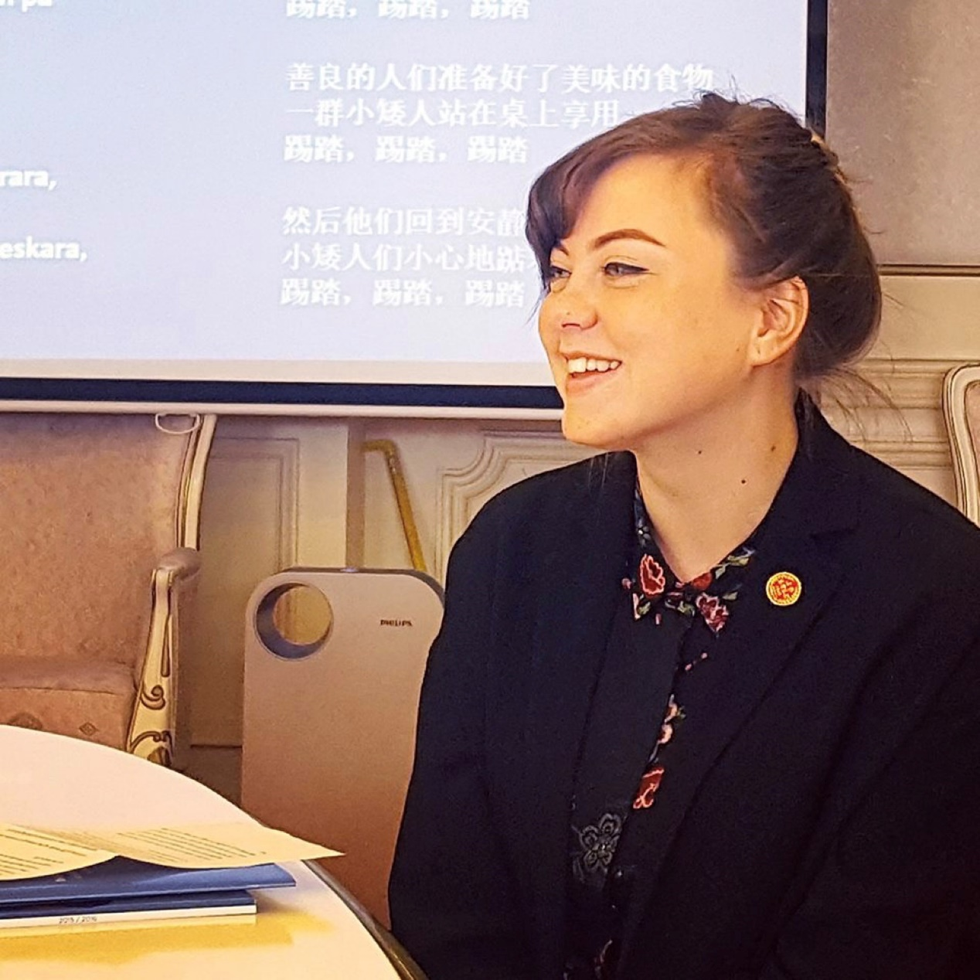
Lin Engdahl has worked as a lecturer at Fudan University, and Shanghai International Studies University since 2015. Lin graduated from Södertörn University, where she studied masters degree in Comparative Literature. She holds a BA in Chinese from Stockholm University.

林·恩达尔，斯德哥尔摩大学中文学士，斯德尔顿大学比较文学硕士，自2015年起在复旦大学和上海外国语大学担任讲师。

