多语种中心欢迎您修读本学期的现代西班牙语课程：
课程代码 | 课程名称 | 任课教师 | 教室 | 上课时间
FORE110050.01 | Spanish I | José D.  Centeno A. | H5417 | Mon.6-7, Wed.6-7, last 3 Fri.6-7  1-17
FORE110050.02 | Spanish I | José D.  Centeno A. | H5417 | Mon.8-9, Wed.8-9, last 3 Fri.8-9  1-17

关于西班牙语

About Spanish
Spanish, the second most spoken language in the world after Mandarin Chinese. And if 100 people lived on the earth, 5 could speak Spanish, according several statistics. Interesting!

西班牙语，是继中文后全球第二最多人使用的口语。根据数个统计，在全球每一百个人当中，就有五个人可以说西班牙语。真是激动人心！

Spanish course at Fudan University is designed by Instituto Cervantes, a non-profit organization founded by the Government of Spain in 1991 (www.cervantes.es). The course accomplishes the Spanish language objectives and contents of level A1 (part 1) according to the Common European Framework of Reference for Languages. It is directed to students who want to have an initial knowledge and a basic communicative competence of Spanish language, which is a good guarantee.

多语种中心的西班牙语课程由塞万提斯学院设计并遴选优秀母语教师任教。秋季课程将完成「欧洲共同语言参考标准」的A1级（第1部分）西班牙语目标和内容，课程主要针对学习西班牙语的初步知识和基本交际能力，是学习初阶西班牙语的很好保证。

我们的课程
Overall Course Goals 课程目标

Students will learn to use simple everyday expressions aimed at meeting basic needs, such as: asking and providing personal information, describing people (individual and family) and home (furniture and locations), asking and telling the time, expressing likes about things and actions and talking about free-time activities and even how to order food at the bar or restaurant with basics and simply ordered.

学生将会学习利用西班牙语作日常生活交谈之用，例如询问及提供个人资讯、描述人物（个人及家人）及家庭（家居及位置）、提问及回应时间、空间时间所做的活动以及在酒吧和餐厅内如何下单叫食物等等。

Methodology 教学方法

The course is based on an active teaching methodology in which students communicate in Spanish through interaction. The teaching-learning process is orientated by activities and tasks stressing the use of the language skills (reading, writing, listening, speaking) with authentic texts to exchange information, such us: information gap activities, simulations, role-plays, interviews, funnies and entertaining games, surveys, pair/groups-works, videos, etc.

课程会以积极的教学方法进行，透过互动的方式与学生以西班牙语作交流。师生将以西班牙语一同进行不同的活动及任务，务求让学生能够掌握西班牙语阅读、写作、聆听、说话各方面的技巧，活动包括模拟活动、角色扮演、访谈、游戏、调查、小组活动及视频等，以生动有趣的形式让学生更全面及容易学习全面的西班牙语。

Because of the distance between Spanish and Chinese, an emphasis on phonetics and basic language structures is needed. So, the previous approach is combined with Audio-lingual and Presentation-Practice-Production methodologies, with exercises like dictations, choral repetitions, substitutions of elements, filling blanks, etc.

由于中文及西班牙语有一定的差距，所以有强调学习音标及基本语文结构的必要。因此，课程将会与音频及演示实践相互结合，练习如默写、齐声练习、元素替换及填充练习等。
Course Material 课程材料

Apart from the formal book “Etapas China A1.1 (Edinumen)”, other teaching materials will be provided by the teacher depending on the lesson topic.

除了 “Etapas China A1.1 (Edinumen)” 书本之外，老师会因应课堂需要而提供其他教学材料。

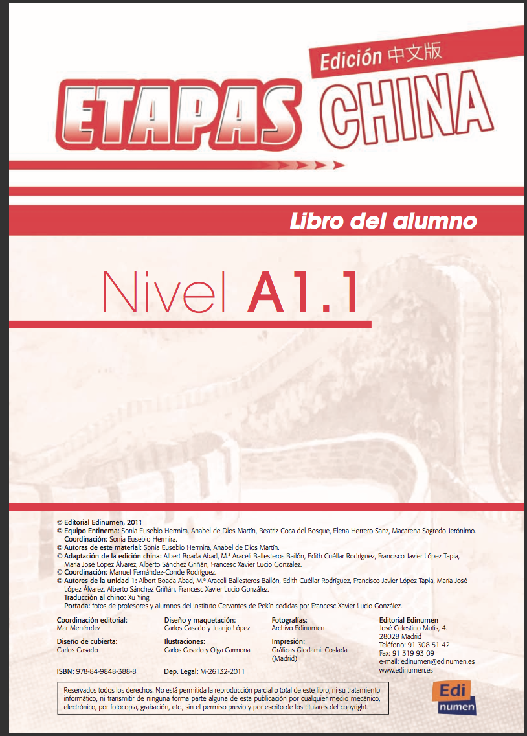

Class Format 学习模式

Each class will have these sections more less:
Warm up (random questions about last lessons, introduction of the topic of study with specific material and review of previous class);
Grammar study;
Interactive activities between students;
Educational games (music, videos, crosswords, etc).

每节课会因应课程需要而进行以下活动
热身（重温上节课的知识，简介学习主题等）
语法学习
师生互动
游戏（透过音乐、视频及填字游戏进行教学）

我们的老师

I have more than four years teaching experience in my country and more than three years Spanish teaching experience in Shanghai. By counting all these, I know that teaching is of paramount importance in my life and what I love to do most. Being taught in the kids and adult courses, they gave me a lot of valuable experience on defending how to do my job best. To be a teacher, you need to be sure that you love what you are doing and also dedicate part of your time to care about your students.
Beside Fudan University, I am teaching in a Science and Technology University, two secondary schools and in a language centre with the Spanish library Cervantes as well. I had been teaching in a Spanish Bank well-known as BBVA in Shanghai too. Also, I am a certified examiner for DELE examination (Spanish certificate for further Spanish speakers) having taken a lot of interviews with the students who want to get that certificate.

在委内瑞拉，我有超过四年的教学经验；在上海，我有超过三年的西班牙语教学经验。教学，绝对是我生命中最重要及最喜欢的事情。我相信要成为一位称职的老师，不单要喜欢教学工作，更需要付出很多的时间去关爱你的学生，过往教导不同的儿童及成人西班牙语班都给了我很多宝贵的经验，让我成为一位更好的老师。
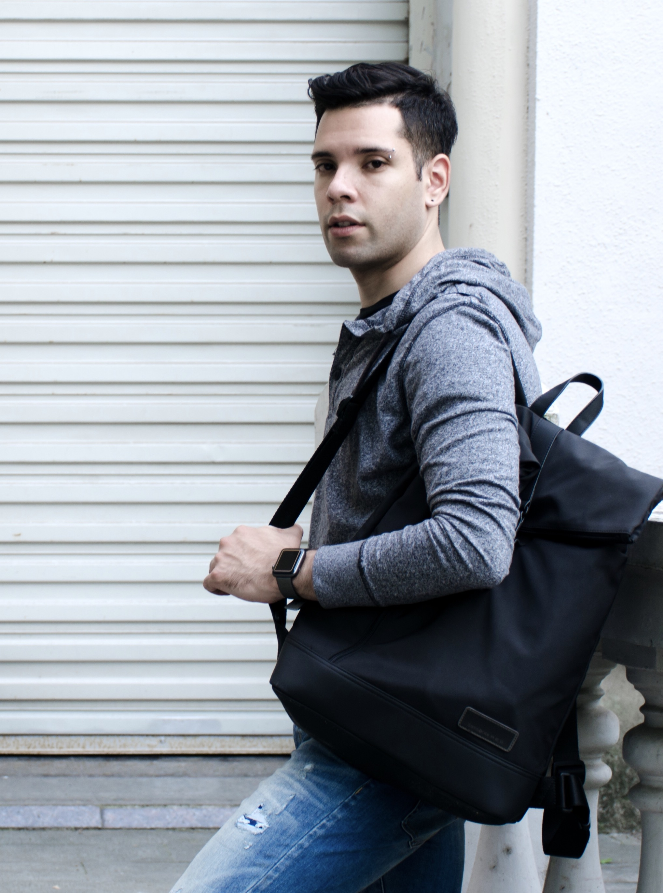
除了復旦大学，我亦是理工大学、两所中学及西班牙语教育中心的老师，也曾经在上海的西班牙银行授课，我还是西班牙语水平测试DELE的考官。

学习者的推荐

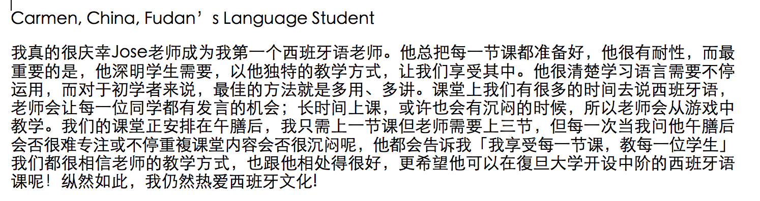
Students’ Opinions on Spanish Language and the Instructor:

