多语种中心欢迎您修读本学期的丹麦语课程：
课程代码 | 课程名称 | 任课教师 | 教室 | 上课时间
FORE130472.01 | SECOND FOREIGN LANGUAGE （Danish）I | Frank Michael Hansen | H5216 | Mon.8-10，Thu.8-10  1-17
FORE110079.01 | Danish I | Frank Michael Hansen | H5107 | Mon.6-7，Thu.6-7  1-17

关于丹麦语
Denmark is an old country with a long and deep history. It is both the centre of the VIKING era and the FAIRYTALE country where H. C. Andersen wrote his famous stories. It is the land of "HYGGE" and the oldest continuous monarchy with Queen Margrethe being the direct descender of Gorm the Old, the Viking king whose son Harald Bluetooth in the year 965 AD let carve the RUNE STONE we today regard as the birth certificate of Denmark:
丹麦是一个历史悠久的古老国度，它既是维京时代的中心王朝，也是安徒生留下脍炙人口故事的童话王国。这是一片舒惬的土壤，是丹麦女王玛格丽特二世继老高姆国王之后统治的古老君主制国家。早在公元965年，维京国王哈拉尔一世命人刻下如尼文石碑, 标志着丹麦王国的正式诞生。

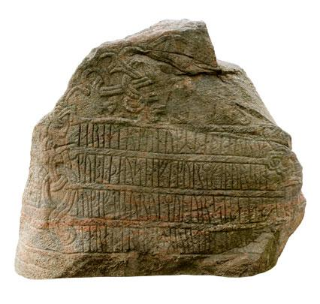
The Danish language is old. Denmark, Norway and Iceland was one country for a very long time and we speak together with the Swedes the Norse language of the Vikings, today it has changed into the modern forms of Danish, Swedish, Norwegian and Islandic. It is however still the Norse language at the root and Icelandic is still quite close to the old form. Danish Grammar is very simple and easy to learn and Chinese students with a good knowledge of English can learn to read Danish in a very short time.
丹麦语是古老的语言。丹麦，挪威和冰岛在很长一段历史时期曾是一个统一的国家，丹麦人和瑞典人都使用维京时代的北欧语言，如今这种语言已经演变成为丹麦语、瑞典语、挪威语和冰岛语等现代语言形式，但它归根结底依旧沿用了北欧语言体系，且冰岛语仍和古语非常近似。丹麦语的语法非常简单易学，精通英语的中国学生可在很短时间内学会丹麦语。
Danish is spoken by close to 6 million people in The Kingdom of Denmark, Faroe Islands and Greenland. Denmark and Norway was a Union for about 500 years and you will find many similarities between Danish and Norwegian. Scania, the Southern part of Sweden, was also a part of Denmark for a long time and Swedish is also coming from Norse thus you will with your Danish potentially understand all these languages and be able to communicate with about 20 million people in all the Nordic countries.
在丹麦王国、法罗群岛和格陵兰岛，有近600万人在使用丹麦语。丹麦和挪威曾有500年的联盟历史，因此你会发现丹麦语和挪威语之间有许多共通点。瑞典南部的斯堪尼亚，在很长一段时间也曾是丹麦王国的一部分，瑞典人也来自挪威后裔。因此，只要掌握丹麦语，你就能够触类旁通，学会其他所有相关语言，同北欧国家近2000万人沟通交流。
Denmark is today a modern and developed country with an advanced service economy. It has a GDP per capita among the highest in the world. It is rich, modern and fast. Copenhagen, our capital, is fast-moving and very successful with a bicycling population. More than 60 % are using the bicycle for work, studies etc. Denmark has world class universities and world class companies and a very well-educated population. It is as competitive and challenging as it is beautiful in the wonderful summers. The Danish classes will give you a very good introduction to this amazing country, and should you decide to visit, information will be provided on how to travel, study and live in Denmark.
今天的丹麦是一个拥有先进服务型经济的现代化发达国家，其人均GDP位居世界前列。它是富饶、现代化、发展迅速的国家。哥本哈根是我们的首都，它发展迅猛，并以其庞大的骑行人口成功实践了这个城市的环保理念 。超过60%的人选择自行车作为工作，学习的出行工具。丹麦拥有世界一流的大学，企业及高素质人才。这个充满机遇与挑战的国家，正如它的美好夏日一般引人入胜。通过对该门课程的学习，你将对这个神奇美妙的国度有更深刻的感悟，更美好的憧憬。如有意向去丹麦旅行，深造或定居，我们非常乐意提供相关信息。

You will in this class learn to speak, write, read and understand Danish as it is used in Denmark today. We will use a communicative approach to give you a functional and very useful Danish language competence. We will use a textbook but also the internet, audio-files, literature, tv programs, newspapers, movies, role-playing and other fun activities. The class will also include introductions to Danish literature (in English).
在这门课程中，你将学习现代丹麦语口语，写作和阅读。以语用沟通为导向的课堂教学能帮助你掌握实用的丹麦语。我们不仅使用教科书，还借助互联网、音频文件、文学作品、电视节目、报刊、电影、角色扮演等各种有趣的活动为你开展课程。该课还包括丹麦文学导论（英文授课）。

课程效果：
Outcome
You can use your Danish for pursuing jobs in Danish companies or studies in Denmark. You will at the completion of the course understand the fundamentals of Danish pronunciation. You will after the course be able to read a Danish book, watch a Danish movie, write a Danish email and speak with a Dane in a simple but very useful Danish.
凭借此项语言能力，你可以在丹麦找工作或从事学术研究。在课程结束后，你能掌握丹麦语发音的基本原理，阅读一本丹麦语书籍，观看丹麦电影，写丹麦语邮件，用简单实用的丹麦语和丹麦人交谈。
You will also have a solid knowledge of the grammar and syntax of Danish as it is used in Denmark today. You will furthermore have acquired a good understanding of salient elements of Danish culture, history and society.
同时，你也将具备扎实的丹麦语语法和句法基础，并对丹麦的历史文化和社会环境有更深的了解。
We hope, as part of the course, to give you access to invitations to visit Danish companies in Shanghai, watch Danish movies, eat Danish food, celebrate Danish public holidays and arrange visits to Denmark. Also, the Nordic Centre may be used for some classes.
作为课程学习的一部分， 我们希望为你们提供位于上海的丹麦企业邀访机会，我们可以一起看丹麦电影，品丹麦美食，度丹麦假日，学院甚至会为你们安排丹麦访学活动。此外，北欧中心也会为某些课程开放。

Teaching Materials & References:
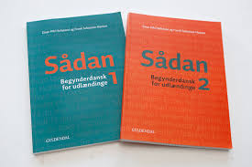
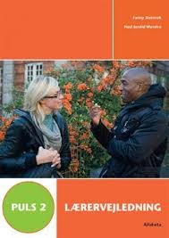

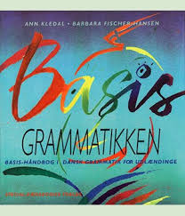

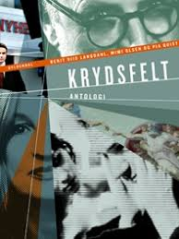

"Sådan 1 – Begynderdansk for udlændinge" Einar Pihl Helleland and Frank Sebastian Hansen, Gyldendal, Copenhagen 2014. ISBN: 9788702144260.
"Sådan 2 – Begynderdansk for udlændinge" Einar Pihl Helleland and Frank Sebastian Hansen, Gyldendal, Copenhagen 2014. ISBN: 9788702144277.
"Puls 2 – Dansk for DU 3" by Fanny Slotrub and Neel Jersild Moreira. Alfabeta, Copenhagen 2015. 3. udgave, 2. oplag. ISBN: 9788763602877.
"Basis-Grammatikken – Basis-håndbog i dansk grammatik for udlændinge" by Ann Kledal and Babara Fischer-Hansen, Special-pædagogisk forlag, 2. udgave, 9. oplag, 2014. ISBN: 9788773996836.***
"Det lyder godt – Grundbog i udtale" af Kirsten Snefstrup og Lars Schmidt Møller, Alfabeta 2010, 1. udgave, 4. oplag. ISBN: 9788763602525.
"KRYDSFELT", Antologi, Gyldendal, Copenhagen 2014. ISBN: 9788702078541

Please observe: More books and readings can and will be added. Some books and materials will be available for the students to borrow for extra reading.
Level and method:
We will follow the Danish DU 3 track (Dansk Uddannelse 3) as defined by the Danish Ministry of Education.
DU 3 is a fast-track Danish language training approach used at the Danish Technical University in Copenhagen for Master students, PhDs and Post Docs.
DU 3 has 5 levels where DU 3:5 is a university entry level of Danish.
I teach Danish 1 the first semester and most likely Danish 2 the second semester and we will probably get to DU 3:3 which is equivalent to B1 in EU Framework System.

我们的老师
Instructor's Academic Background:
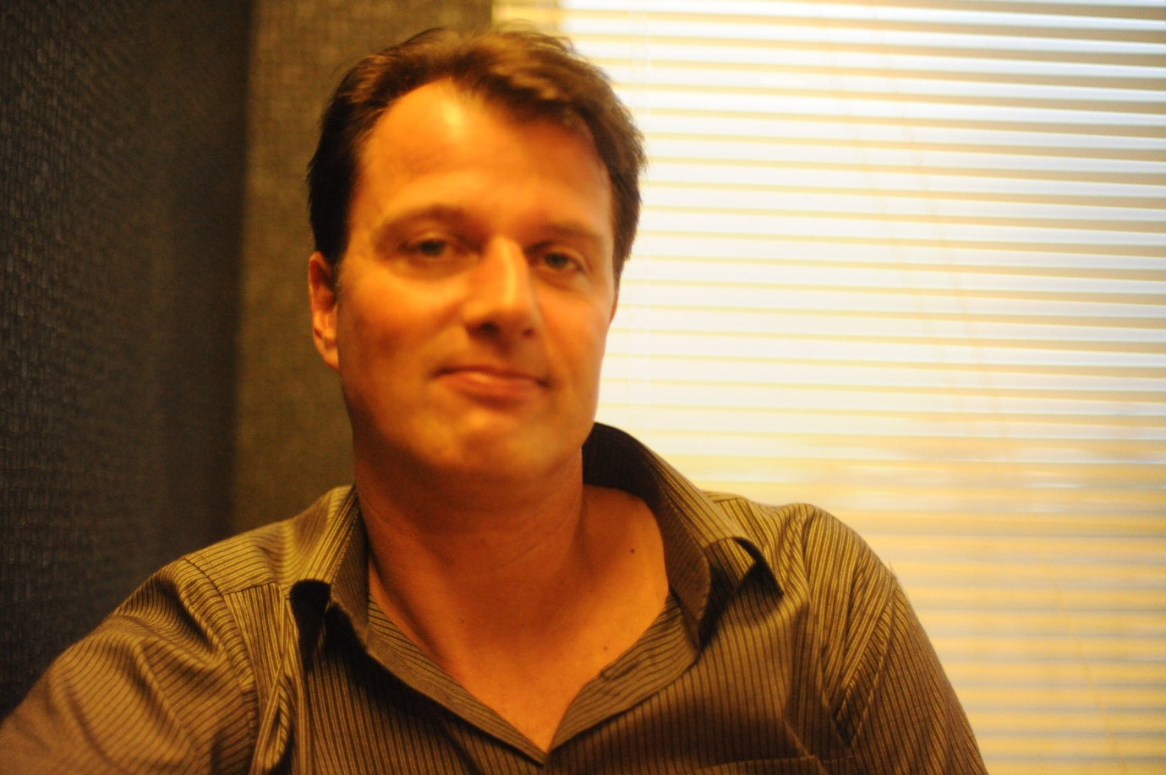

Frank Michael Hansen from Copenhagen, Danmark. BA in Danish Computational Linguistics (plus MA in International Studies from Joseph Korbel School at Denver University, USA), Cand.Mag. in Danish, Copenhagen University. Served 1 year as Danish teacher at Danish Upper Secondary School, 2 years as Danish teacher at the Danish Technical University in Copenhagen, 3 years lecturing and teaching in China in Beijing and Guangzhou and 1 year as Danish teacher at Fudan University, Shanghai, China.
Frank Michael Hansen，丹麦人，哥本哈根大学丹麦语计算语言学文学学士，美国丹佛大学国际关系文学硕士，哥本哈根大学丹麦语文学硕士。曾任教于丹麦高级中学，丹麦科技大学; 在北京，广州有三年执教讲学经历。目前为复旦大学外文学院多语种中心丹麦语讲师。

